1 Integration of tabulated data.

function avg=avg(t,r)
t=[338 423 474 506 557 573 601 622 651 661 671];
r=[9.38 9.90 10.42 10.94 11.46 11.98 12.50 13.02 13.54 14.06 14.58];
T=t.*r;
avg=sum(T)/sum(r);

% svar 565.9655

Solution
Our approximation of the average temperature T is 565,9655 ºC.

2 Simpson quadrature

Task 2a
Integration of Lagrange interpolating polynomial

P₂(x) = f(0)L₀²(x) + f(1/2)L₁²(x) + f(1)L₂²(x)

where the values of L₀²(x), L₁²(x) and L₂²(x) are given bye the Lagrange polynomials :

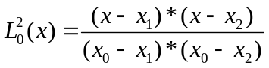

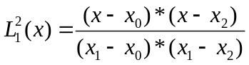

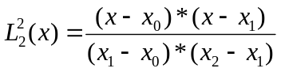

The known values in the equations are 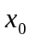,and 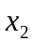 and there resp. values are 0, 0.5, 1.
Bye integrating the equations we get

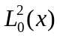= 1/6
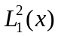= 4/6
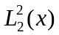=1/6

which are the values in Simpson’s rule.

Task 2b

Our plot of the error diagram loglog.

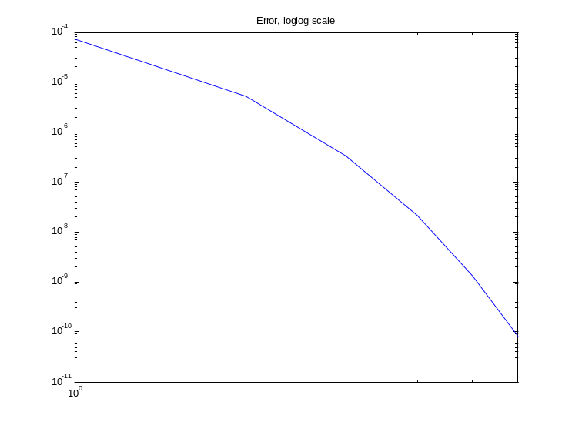

3 Gauss quadrature

Task 3a

The knots c_{j} are given by 2c_{j}-1= γ_{j} where γ_{j} are the roots of the Legendre polynomial

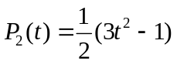
This gives 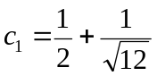 and 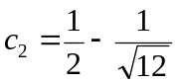

We compute b₁ and b₂ by using the formula

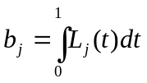

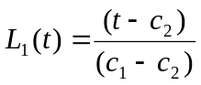, 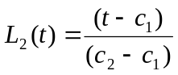

which give the values b₁=0.5 and b₂=0.5.
Task 3b

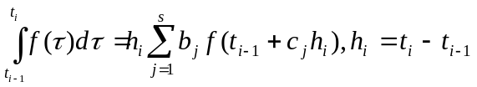 in our case 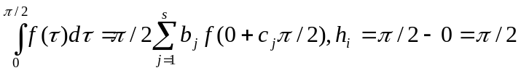 where 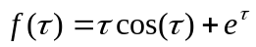which gives 